|  |
| --- |
| This document provides you with information about our Sickness Income Plan and should be read in conjunction with information provided when you originally took out your policy. |
| This product is a **Sickness Income Plan** provided by Unity Mutual.  You can find detailed information about us on our website at [www.unitymutual.co.uk](http://www.unitymutual.co.uk) |
| **What is this product?** |
| **Objectives:** The Unity Mutual Sickness Income Plan (SIP) is designed to provide members with financial assistance during periods of illness. The Plan provides a unique opportunity to protect yourself, and your family members against the increased expenses of illness, and at the same time provides you with your own savings account which attracts tax-exempt* interest.  **How does it work:** You pay monthly contributions to the plan.  On 31st December each year, a proportion of what you have paid during the year (currently 80%) is transferred to a fund in your name called your “Member’s Fund”.  The remaining portion (currently 20%) goes into Unity Mutual's funds and is used to pay administration costs and sickness benefits.  The money in your Member’s Fund then earns interest which is tax exempt.  **Intended retail investor**:Membership of the Plan is open to everyone aged 18 to 69.  You might consider this plan if you want to provide an income when you are sick and also have an opportunity to make tax exempt savings*.  You should see the SIP as a long term investment.  **How much can you invest:** You can pay from £4.00 to £70.00 per month by direct debit and, you can change your contributions at any time, in £2.00 increments within these limits. Any increases are dependent on your state of health at the time. |
| **What are the risks?** |
| Your circumstances may change, forcing you to cease contributions.  The funds of Unity Mutual are invested, and the value of these funds may rise and fall. The interest rate and the proportion of the refund of contributions made annually to members could also vary.  The Management Charge may rise or fall during the period of membership. |
| **What are the sickness benefits?** |
| **How much can you claim?** The benefit you can claim depends on your rate of contribution and the amount built up in your Members Fund. Whatever you pay in each month becomes the Sickness Benefit per day, so, £40 per month contribution will provide £280 of Sickness Benefit per week.  **When am I entitled to receive benefits?** You are not entitled to sickness benefits in the calendar year you join Unity Mutual. You can however obtain immediate cover by placing some money in a Deposit Account in addition to paying your monthly contributions (subject to Unity Mutual rules).  **Do I have to be hospitalised to receive benefit?** No! We will pay Sickness Benefit from the first day of illness stated on your original medical certificate, whether in hospital or at home. Weekends and holidays are also included, so as to provide cover all year round. |
| **What is the "Member's Fund"?** |
| At the end of each year, Unity Mutual returns a proportion of contributions to members by crediting this to their fund. Currently this is 80%. This percentage could go down as well as up in future. In addition, interest on the balances in Members' Funds is currently tax-exempt*.  **What if I am seldom or never ill?** The money in your Member’s Fund is yours. The amount in your fund can be paid to you as a lump sum, less any penalty, if applicable. |

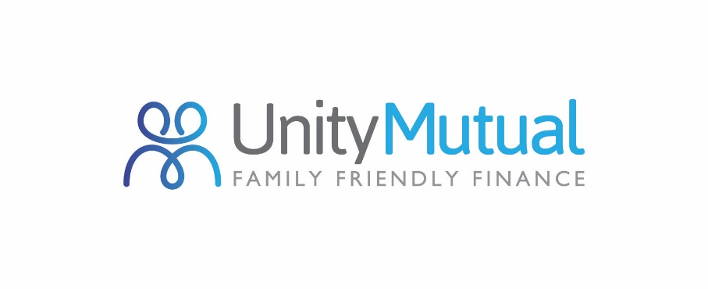

**Sickness Income Plan**

**Factsheet**

16 April 2018

|  |
| --- |
| **Maximising your benefits** |
| Initial contributions range from £4 to £70 per month (plus management fee); and can be increased in increments of £2; the daily sickness benefit will be the same level as the monthly contribution. For example, £50 contribution per month could entitle you to £350 per week or £18,250 per year in sickness benefit.  Members thinking of increasing contributions should bear in mind the effect of Unity Mutual’s classifications:   |  |  |  | | --- | --- | --- | | **AGE** | **CLASS** | **COMPOSITION OF BENEFIT** | | Under 35 | A | 1/4 your fund and 3/4 Unity Mutual funds | | 35 and under 45 | B | 1/3 your fund and 2/3 Unity Mutual funds | | 45 and under 50 | C | 1/2 your fund and 1/2 Unity Mutual funds | | 50 and under 69 | D | 2/3 your fund and 1/3 Unity Mutual funds |   Your existing contributions will remain at their current levels; only the increased elements will be set to the appropriate classification for your age at the time of the increase.  When considering applications for increase, we will take into account previous sickness record and current medical condition. When granted, members will not be eligible for benefit at the increased level until six months have elapsed from the date of the first increased payment. Your Direct Debit will be amended to the new rate of contribution automatically and you will receive notification in writing |
| **How does the Deposit Account work?** |
| Members of the Sickness Income Benefit Plan can invest money with us in a separate Deposit Account, and some of the money in this account can also be used to extend sickness benefit. The maximum annual lodgement you can make is four times the annual contribution to the Sickness Income Benefit Plan and any interest paid on these accounts is tax-exempt*. |
| **What happens if Unity Mutual is unable to pay out?** |
| We are covered by the Financial Services Compensation Scheme. If we cannot meet our obligations you may be entitled to compensation under the scheme.  Further information on the scheme, the amounts covered and how it can be obtained from the Financial Services Compensation Scheme can be found at [www.fscs.org.uk](http://www.fscs.org.uk). or by calling Tel: 0800 678 1100. |
| **What are the charges?** |
| **Management charge:** A Management Charge (currently 50p per month) is payable in addition to your contributions.  **How much is taken from the Member’s Fund when I am ill?** Only a proportion of Sickness Benefit comes from the Member’s Fund, the balance coming from Unity Mutual’s own funds. Currently, if you joined before age 35, then 25% of your Sickness Benefit would be taken from your fund, and 75% would be paid by Unity Mutual.  If your fund becomes exhausted, sickness benefit ceases until the following January (but see the question later on the Deposit Account facility). |
| **How long should I hold it and can I take money out early?** |
| You can continue contributing after retirement, whether at normal retirement age or earlier. Sickness benefits are payable up to age 70.  If you wish to withdraw monies you can, subject to you leaving in a minimum amount equal to previous two year’s contributions, thus ensuring that some funds are there if you fall ill.  If you choose to leave the Plan before retirement, there will be a penalty, currently equal to one year's contributions.  In the event of you ceasing to make contributions whilst still remaining a member, then your contributions will be taken from your accumulated fund until this runs out and membership lapses. |

|  |
| --- |
| **How can I complain?** |
| If you wish to complain about any aspect of the service you have received, please contact the Compliance & Risk Officer, Unity Mutual, Oddfellows House, 184-186 Deansgate, Manchester, M3 3WB. (Tel: 0161 214 4650)  If your complaint is not dealt with to your satisfaction, you can then complain to the Financial Ombudsman Service, Exchange Tower, London E14 9SR. Tel: **0800 023 4 567/0300 123 9 123** (opening hours are: Monday to Friday - 8am to 8pm, Saturday - 9am to 1pm), Email: [complaint.info@financial-ombudsman.org.uk](mailto:complaint.info@financial-ombudsman.org.uk) Web:  [www.financial-ombudsman.org.uk/](http://www.financial-ombudsman.org.uk/). Making a complaint will not prejudice your right to take legal proceedings. |
| **Other relevant information** |
| You can find other information relevant to our Sickness Income Plan in the following documents:   * Terms & Conditions of the Sickness Income Plan * Services and Costs Disclosure Document   These documents and information about the Unity Mutual can be found on our website [www.unitymutual.co.uk](http://www.unitymutual.co.uk)  Under the EU Solvency II Directive we are required to make our Solvency and Financial Condition Report available to the public each year. You can find this at <https://www.unitymutual.co.uk/money/customer-centre/annual-reports/>  Unity Mutual is authorised by the Prudential Regulation Authority and regulated by the Financial Conduct Authority and the Prudential Regulation Authority, registration No. 109995  Unity Mutual is authorised by the UK Regulators to market and/or administrate Tax Exempt Savings Plans, Qualifying policies, Personal Pensions, Investment Bonds, Life Assurance, Stocks and Shares ISAs, Junior ISAs and Child Trust Funds.  You can check this on the Financial Services Register by visiting the FCAs website  [www.fca.org.uk/firms/systems-reporting/register](http://www.fca.org.uk/firms/systems-reporting/register) or by contacting the FCA on 0800 111 6768  **\*Tax-exempt status and Taxation:** Friendly Societies currently enjoy a special taxation status. Sickness Benefit is not currently liable for income tax, and money in Members’ Funds and Deposit Accounts also benefit from special tax concessions available to tax-exempt funds. This means that no tax is paid by Unity Mutual on capital gains or income received from cash deposits and fixed interest securities. No tax is payable by members on the interest on funds received by them or on withdrawal of those funds. It should be remembered that the levels and basis of taxation might change. |